Mark Skidmore/Guilherme Martins

CS302 Data Structures
Fall 2008 - Dr. George Bebis

Programming Assignment 3
Due Date: 11/5/2008

I. Introduction

The primary purpose of this program is to perform and demonstrate coin recognition from gray-level images. Specifically, the program will read in a gray-level image of coins and perform the following actions:

- Produce a corresponding histogram of the pixel values of the read-in image
- Perform automatic thresholding from the histogram
- Perform automatic Dilating and Eroding of the read-in image
- Provide the user with the choice of performing the counting and labeling using Breadth First-Search (BFS) or Depth-First-Search (DFS) algorithm of the dilated/eroded image

Each of the above steps is detailed in the Program Usage description. The BFS and DFS are further explained in Section III. A.

II. Program Usage

The program is simple to use. In a command window, navigate to the folder containing the program files. Then from the command line, simply run the executable by typing ./processImage.bin and follow the on-screen prompts and menu as shown below in Illustration 1.

The program will first ask the user to enter the name of a file to process. This image will then be used throughout the program until the user exits the program.

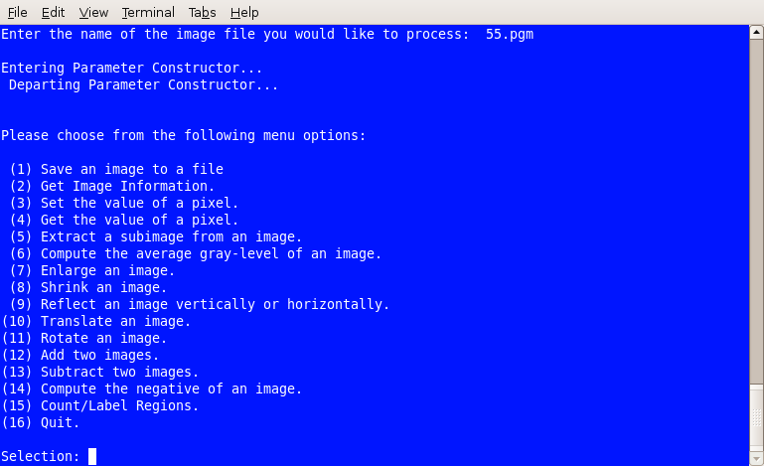Illustration 1: Menu List
Because menu items 1 through 15 have already been demonstrated in Assignment 1, only menu item 15 will be demonstrated in this report.
Upon entering menu item 15, the program will create a histogram image from the read-in image. The histogram should be composed of two peaks – the first peak is that of the non-coin pixel values while the second peak is that of the coin pixel values. The program asks the user to enter a filename for the histogram. The user can type in any filename then press Return.

The program then uses the histogram image to find the optimum threshold value of the coin image which is the lowest pixel value between the two peaks. Thresholding attempts to produce a binary (black and white) image by separating non-coin pixels (background) from coin pixels and labeling the background as black and each coin’s image as white. Once the optimum value is found, the read-in image is then thresholded and the program asks the user to enter a file name for the newly-created thresholded image to be written to disk.

Because thresholded images are usually not completely perfect, i.e., the coin images which should be completely white, they might have black spots or small holes in them. We would like to “clean” the image as much as possible by filling the small holes. There are two algorithms which, when used in succession, should alleviate most of the small holes. The first algorithm is dilation which attempts to fill the small holes with white pixels but also expands the image in doing so. Therefore, the erosion algorithm is immediately performed to reduce the dilated coins’ images to their original sizes. The program uses these two algorithms automatically on the thresholded image and when complete, asks the user to enter a file name for the cleaned image.

Upon completion of dilation and erosion, the cleaned image is ready for counting and labeling. The program asks the user to choose between BFS or DFS then performs the counting and labeling by using either a queue or stack, respectively. Once the cleaned image has been processed, the program asks the user to enter a file name for the final image which contains corresponding labels of the original coins’ images in a new image file.

Each of the steps described above is shown below in Illustration 2.

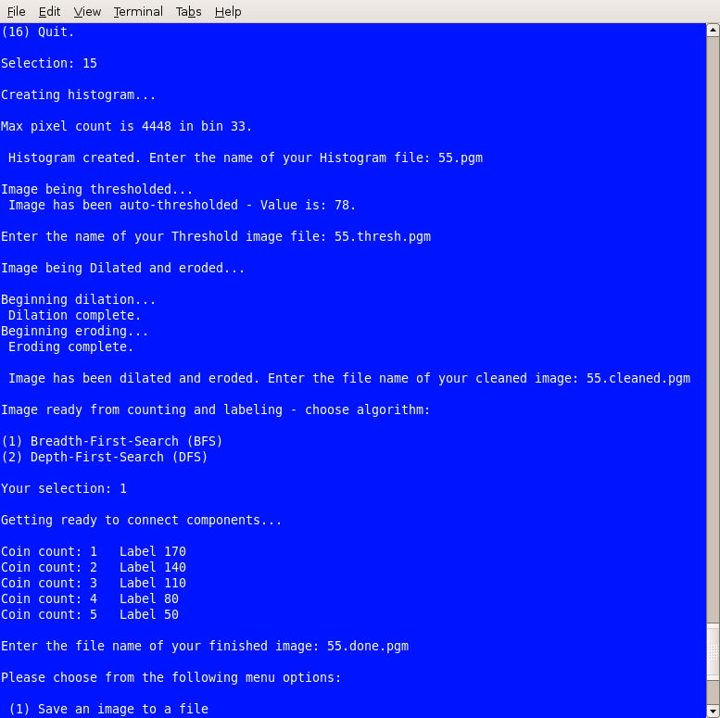Illustration 2: Program Run

III. Program Implementation and Results

A. The Client Functions.

The main driver program, processImageMain.cpp, contains the following functions which are briefly described below: (Note: reference to class methods in this section are abbreviated by omitting parameters; full method descriptions are provided in Section III.B.)

void executeCases(int choice, int N, int M, int Q, ImageType& image);

Provides the switch statement to accept and execute user's menu choice. Also accepts row (N), column (M), number of gray-level values and an image object which are parameters that are used throughout the switch.

void setPixelValues(int N, int M, ImageType& image);

Prompts user for desired row, column and pixel value parameters in order to set a user-defined pixel value at a user-defined row and column coordinate. Receives row (N), column (M) and image object parameters from executeCases() function that are used to validate user input. Calls class method setPixelVal(row, column, PixelValue). Prior and post- pixel coordinates and values are displayed on the screen.

void getPixelValues(int N, int M, ImageType& image);

Prompts user for desired row, column and pixel value parameters in order to get a pixel value at a user-defined row and column coordinate. Accepts row (N), column (M) and image object parameters from executeCases() function that are used to validate user input. Calls class method getPixelVal(row, column, PixelValue). Pixel coordinates and values are displayed on the screen.

void extractImage(int N, int M, ImageType& image);

Prompts user for desired upper-left and lower-right, row and column corner coordinates which are used in computing the boundaries of a sub-image. Accepts row (N), column (M) and image parameters which are use in the class call getSubImage(). Class method writeImage() writes the extracted image to a user-named file.

void computeAvgGrayLevel();

Computes the average gray level of an image. User is prompted for the file name of an image to process. ReadImageHeader() function is called and reads header information; a new image is then instantiated and passed to readImage() function which reads the image information. Class call to computeAvgGrayLevel() computes, returns and displays average gray level.

void enlargeImage(ImageType&);

Enlarges an image. Receives image object from executeCases() and prompts user for an enlargement factor, calls class method enlargeImage(), prompts user for an output file name and calls writeImage() to write new enlarged image to disk.

void shrinkImage(ImageType&);

Shrinks an image. Receives image object from executeCases() and prompts user for a shrink factor, calls class method shrinkImage(), prompts user for an output file name and calls writeImage() to write new reduced image to disk.
void reflectImage(ImageType&);

Reflects an image either vertically or horizontally. Receives image object from executeCases(),calls class method reflectImage(), prompts user for an output file name and calls writeImage() to write new reflected image to disk.

void translateImage(ImageType&);

Translates an image in the - X and + Y directions. Receives image object from executeCases(),calls class method translate.Image(), prompts user for an output file name and calls writeImage() to write new reflected image to disk.

void rotateImage(int N, int M, ImageType& image);

Rotates an image between a user-defined -360 and 360 degrees. Receives row (N), column (M) and image object parameters from executeCases() function. User is prompted to enter rotation angle which is converted to radians. Class method rotate.Image() processes rotation; function then prompts user for an output file name and calls writeImage() to write new rotated image to disk.

void negateImage(ImageType&);

Computes the negative of an image. Receives image object from executeCases(),calls class method negateImage(), prompts user for an output file name and calls writeImage() to write new negated image to disk.

void useOverloadPlus(ImageType&);

Adds two images. Receives image object from executeCases(),instantiates two image objects to be used in performing addition process; uses class overloaded operators + and =; prompts user for an output file name and calls writeImage() to write new added image to disk.

void useOverloadMinus(ImageType&);

Subtracts two images. Receives image object from executeCases(), instantiates two image objects to be used in performing subtraction process; uses class overloaded operators - and =; prompts user for an output file name and calls writeImage() to write new added image to disk.

void countLabelRegions(int N, int M, int Q, bool type, ImageType& image)

The primary function to perform coin recognition. Upon the user choosing menu item 15, this function is called and passes row (N), column (M), maximum gray-scale values (Q), and the image to be processed (type is not used but reserved for future use). Within this function, the program calls the following functions from the image class: histogram() to produce the histogram; threshold() to produce the thresholded image; dilate() and erode() to perform dilation and erosion on image; and connectedComponents() to count, label and produce the labeled image file. (NOTE: see each function for specific parameters which are passed in a call).

int connectedComponents(ImageType& image, ImageType& outputImage, int choice)

Receives cleaned image from countLabelRegions() function and calls findComponentsBFS() or findComponentsDFS() function based on user's choice. Returns coin count.

void findComponentBFS(ImageType& image, ImageType& outputImage)

Finds connected components in binary image using a queue to process image and produce corresponding outputImage with counted and labeled coins. The algorithm uses eight pixels in the form of a 3 by 3 square surrounding a center pixel, (I, j), of image. Each of these neighbors is stored in the queue so that they can be labeled in future iterations.

void findComponentDFS(ImageType&, ImageType&);

Finds connected components in binary image using a queue to process image and produce corresponding outputImage with counted and labeled coins. The algorithm uses eight pixels in the form of a 3 by 3 square surrounding a center pixel, (I, j), of image. Each of these neighbors is stored in the queue so that they can be labeled in future iterations.

B. The Image Class Functions.

ImageType();

The default constructor. Sets row, column, gray-level values to zero; sets pixelValue member to NULL

ImageType(int, int, int);

The parameter constructor. Accepts temporary row, column and gray-level parameters then returns current respective values. Sets all pixel values to zero.

ImageType(const ImageType &object);

Implemented and tested but not used.

void getImageInfo(int& rows, int& cols, Int& levels);

Returns by reference the number of rows and columns of the image, and the max pixel value.

void getPixelVal(int i, int j, int& val );

Returns the pixel value by reference at (i, j) location. Bounds checking is done in main (but should have been done in this function to provide more robustness to client calls).

void setPixelVal(int i, int j, int val);

Sets the pixel value at location (i, j) to val. Bounds checking is done in main (but should have been done in this function to provide more robustness to client calls).

int computeAvgGrayLevel(const ImageType &object);

Returns the average gray-level of object. For each row then for each column, sums all pixel values in the 2D array then divides by the number of cells (row x columns) to compute an average.

ImageType enlargeImage(int e, ImageType &object);

Enlarges object. Instantiates a temporary Image object to store object parameter by row then by column processing. A second temporary object is instantiated then set equal to object using a row loop from 0 to rows times e and a column loop from 0 to columns times e while the object's rows and columns are set to i/e and j/e, respectively. Returns an image type object.

ImageType shrinkImage(int s, ImageType &object);

Reduces object. Instantiates a temp object and populates with object using two nested for loops then zeroizes the original object. Next, uses row and column nested for loops and increments by s in each loop, cycles through each cell of the temp object and assigns to corresponding object rows and columns divided by s. Then, uses previous loop structure but with column upper bound divided by s, assigns temp cells to corresponding object cells, again with columns divided by s. Lastly, with two nested for loops with upper bounds divided by s but one less than number of rows and columns, respectively, object is assigned to previously instantiated second temp object. Returns second temp object.

void getSubImage(int ULr,int ULc, int LRr,int LRc, ImageType& object)

Returns a sub-image of object. Instantiates a temp image object to which object is assigned then object is zeroized. Two nested for loops, from Upper-Left row (ULr) to Lower-Right row (LRr) and from Upper-Left column (ULc) to Lower-Right column (LRc) then re-populate object with temp object values. Returns object by reference.

void negateImage(ImageType &object)

Negates object. For each row and column of object, object is assigned the absolute value of 255 minus each pixel value of object. Returns object by reference.

void reflectImage(ImageType &object)

Reflects object about the vertical or horizontal axis. Object is assigned to instantiated temp object then zeroized. User is then asked to choose between horizontal and vertical reflection. A switch statement then performs the corresponding choice. Both reflections use two nested for loops – the horizontal's column loop descends from column less one while the vertical's row loop descends from row less one. Reflected image is returned by reference.

ImageType translateImage(int t, ImageType &object)

Shifts an image in the -X and +Y directions by amount t. Assigns object to instantiated temp object. If each row and column index plus the translation amount sum to less than the object's row and column values then the translated values are set in temp and temp is returned by reference.

void rotateImage(int N, int M, float theta, ImageType &object)

Rotates object by a user-specified angle. Object is assigned to instantiated temp object then zeroized. New row and column coordinates are then computed with the following formulas:

R = Xc + int(((i - Xc)*(cos(theta)) - (j - Yc)*(sin(theta))) + 0.5);

C = Yc + int(((i - Xc)*(sin(theta)) + (j - Yc)*(cos(theta))) + 0.5);

where Xc and Yc are N/2 (row) and M/2 (column), respectively; theta is the angle in radians, i and j are row and column incrementers, respectively. Casting is performed to convert calculations to an integer while the addition of 0.5 rounds the integers to the nearest integer. Bounds checking is performed to set pixel values to zero for those R and C coordinates that fall outside of object's row and column dimensions. Returns rotated object by reference.

bool inBounds(int R, int C)

Performs row and column bounds checking for rotateImage();.

ImageType displayHistogram(ImageType& object, int& valley)

Called from countLabelRedions() in processImageMain.cpp; counts each pixel value in each cell of object and stores in a 1-D array from 0 to 255. Performs smoothing to facilitate thresholding in threshold() function. Finds threshold value of object and stores in valley. Returns histogram object.

void threshold(int threshold, ImageType &object)

Called from countLabelRegions() in processImageMain.cpp; uses threshold to produce a binary image of object.

void dilate(ImageType& object)

Called from countLabelRegions() in processImageMain.cpp; receives binary (black and white) object and attempts to fill the small holes with white pixels which thresholding missed. Image is expanded during dilation and must be eroded using erode() function.

void erode(ImageType& object)

Called from countLabelRegions() in processImageMain.cpp; receives dilate object from dilate() then returns each coin in object to its original size.

void operator= (const ImageType &object)

Used when overloaded + and – operators are invoked.

ImageType operator + (ImageType &object)

Used to add two objects.

ImageType operator - (ImageType &object)

Used to subtract one object from another.

~ImageType()

Releases memory used by pixelValue row pointers then pixelValue double pointer upon program termination.

C. The Stack Class (stack.cpp) Functions.

Stacktype()

Default constructor; sets private member, nodetype top, to NULL.

void push(int pushi, int pushj)

Used in findComponetDFS() function. Pushes row nodetype I or column nodetype j (seed pixel) onto the stack.

void pop(int& popi, int& popj)

Used in findComponetDFS() function. Pops row nodetype I or column nodetype j (seed pixel) from the stack.

bool isEmpty()

Returns true if there are no elements on the stack; otherwise false.

bool isFull()

Returns true if there is no room for another element on the free store; otherwise false.

void makeEmpty()

Empties the stack of all elements.

~stacktype()

Calls makeEmpty() function to deallocate all elements.

D. The Queue Class (queue.cpp) Functions.

queuetype()

Default constructor; sets private members, nodetype qFront and nodetype qRear, to NULL.

void enqueue(const int& enqi,const int& enqj)

Used in findComponetBFS() function. adds row nodetype I or column nodetype j (seed pixel) to rear of the queue.

void dequeue(int& deqi, int& deqj)

Used in findComponetDFS() function. Removes row nodetype I or column nodetype j (seed pixel) from the front of the queue.

bool isEmpty()

Returns true if there are no elements in the queue; otherwise false.

bool isFull()

Returns true if there is no room for another element on the free store; otherwise false.

void makeEmpty()

Deallocates all elements from the queue.

~queuetype()

Calls makeEmpty() function to deallocate all elements.

E. The NodeType Class (node.h) Functions.

nodetype() {i = 0; j = 0; next = NULL; }

Default in-line constructor; sets public members row I and column j to zero; sets next pointer to NULL.

F. Supplied Functions (Supplied by Dr. Bebis and restated here for document completion).

int readImageHeader(char[], int&, int&, int&, bool&);

Reads the header information of an image file. Stores the filename in char[],tests for a valid file. If file is valid, reads the header and test for P5 (PGM) or P6 (PPM) image types If P5, retrieves row, column and max pixel value information.

int readImage(char[], ImageType&);

Reads an image from a file. The pixel values are stored in an array and the image width, height, and number of gray-levels are recorded in the appropriate fields. A NOT-PGM exception should be raised if the image file to be read is not in PGM format (image is an object of type ImageType).

writeImage(fileName, image):

Writes an image to a file using a user supplied filename in the appropriate format (image is an object of type ImageType).

G. Results

The program executes as expected. The program uses one image for all functions. The user should take note that any successive operation operates on the most recent operation. If the user would like to perform an individual function on image without the previous effect of an operation, he/she should exit the program then reload the desired image and perform the desired operation. No major significant issues were observed.

Note: Dilation must run before Erosion. Calling Erosion before Dilation will cause a segmentation fault.

As stated in the beginning, only menu item 15 was demonstrated in this report. See Assignment 1 for a demonstration of menu items 1 through 14. Also, because stack and queue operations are standard, they are described briefly but succinctly.

IV. Bugs and Errors

None noted.

VII. Partner Contributions.

Both partners contributed 50% each to the assignment.

